**Figures**

Figure 1.

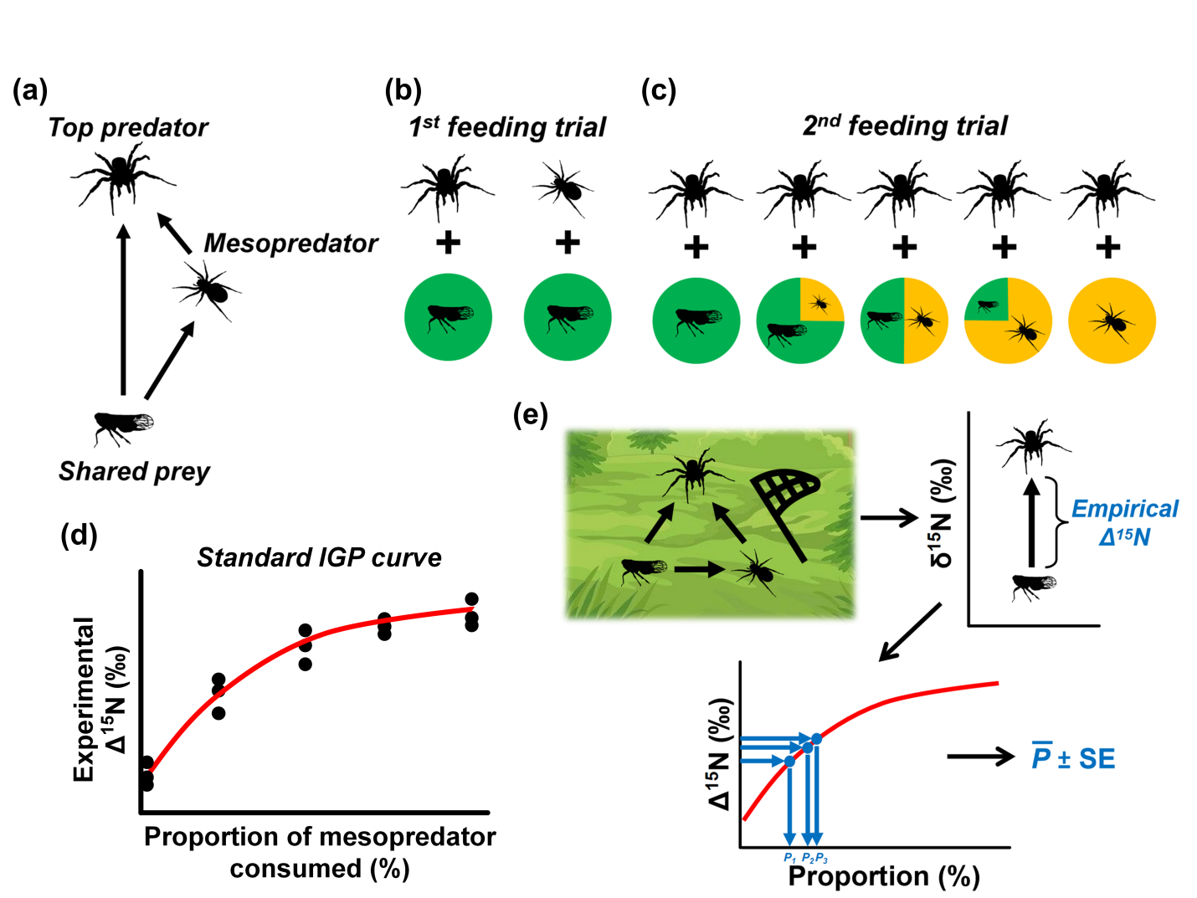

Figure 1.A schematic diagram of the proposed experimental framework for quantifying the degree of intraguild predation (IGP) in an omnivorous food web consisting of a spider top predator, a spider mesopredator, and a planthopper shared prey. See “The proposed experimental framework” section for detailed descriptions of the framework procedures.

Figure 2.

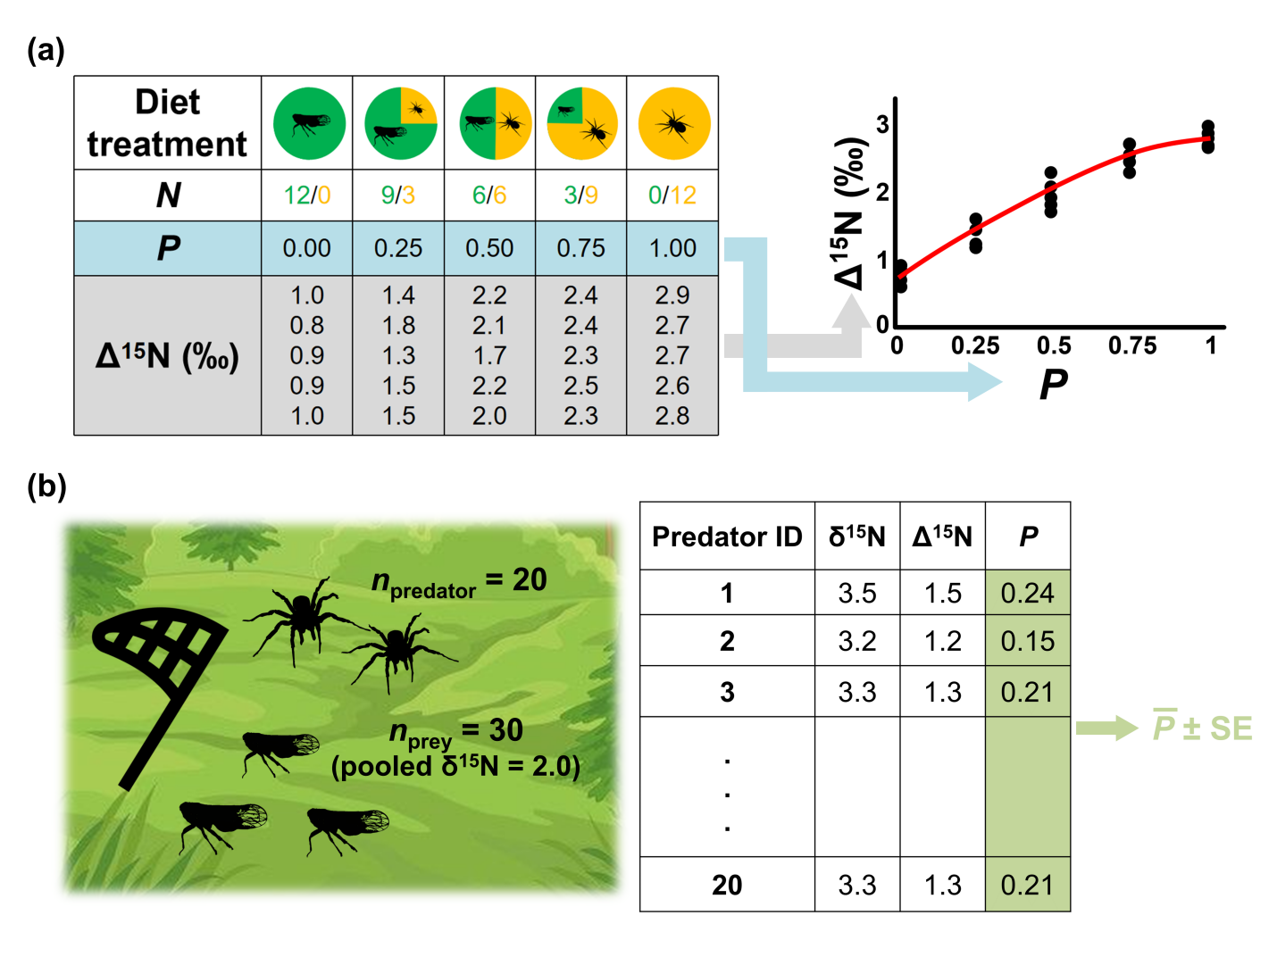

Figure 2. A hypothetical example of (a) standard IGP curve construction in the second feeding trial and (b) IGP estimation using field samples of top predator and the shared prey. *N*: number of shared prey/mesopredator in the mixed diet; *P*: proportion of mesopredator consumed by top predator (%).